**AUTOMATIC COOLING SYSTEM IN COMPUTERS USING MATLAB**

AIM:

To find the internal temperature of a computer system using power series

Mathematical background:

In mathematics, a power series (in one variable) is an infinite series of the form

\sum_{n=0}^\infty a_n \left( x-c \right)^n = a_0 + a_1 (x-c)^1+ a_2 (x-c)^2 + a_3 (x-c)^3 + \ldots

where an represents the coefficient of the nth term, c is a constant, and x varies around c (for this reason one sometimes speaks of the series as being centered at c). This series usually arises as the Taylor series of some known function.

Power series solution:

Consider the second-order [linear differential equation](https://en.wikipedia.org/wiki/Linear_differential_equation)

a_2(z)f''(z)+a_1(z)f'(z)+a_0(z)f(z)=0.\;\!

Suppose a2 is nonzero for all z. Then we can divide throughout to obtain

f''+{a_1(z)\over a_2(z)}f'+{a_0(z)\over a_2(z)}f=0.

Suppose further that a1/a2 and a0/a2 are analytic functions.

The power series method calls for the construction of a power series solution

f=\sum_{k=0}^\infty A_kz^k.

If a2 is zero for some z, then the Frobenius method, a variation on this method, is suited to deal with so called singular points. The method works analogously for higher order equations as well as for systems.

Matlab code:

clc

clear all

syms x a0 a1 a2 a3

a = [a0 a1 a2 a3];

y = sum(a.\*(x).^[0:3])

dy = diff(y);

d2y = diff(dy);

ode = collect(d2y+y,x)

initcond1=strcat(char(subs(y,x,0)),'=1')

initcond2=strcat(char(subs(dy,x,0)),'=1')

odecoeff1eq = '2\*a2+a0=0';

odecoeff2eq = '6\*a3+a1=0';

[a0 a1 a2 a3] = solve(initcond1,initcond2,odecoeff1eq,odecoeff2eq)

soln = subs(y)

Output:

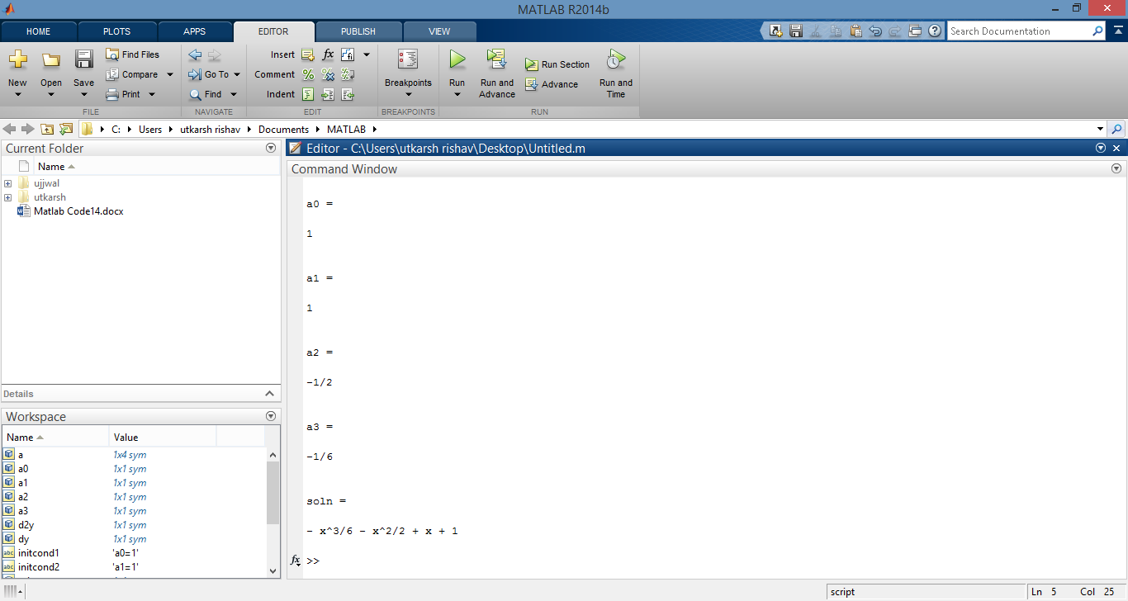

Engineering interpretation:

Differential equation is used to find whether a device is overheated or not .A differential equations is given as input and the solution to it is found and the value of resultant solution is found at point(temperature).If the vaue is above critical value(can be given any value manually) then automatic cooling system will be activated.If not it doesn’t get activated.

The value of temperature is substituted in place of x to get the desired value which is checked .If the value of greater than a specified limit then aautomatic colling system is activated. Differential equation is definitely an important part in games.Apart from jumping and moving,it is also used to do many other movements like shooting a gun(where bullet position is calculated on the basis of differential equations),driving a car(car’s position based on acceleration and deceleration is calculated by differential equations),running,etc

Example:

\begin{displaymath}y''-4y'+3=0,\quad y(0)=1,\ y'(0)=2.\end{displaymath}

The generic form of a power series is 

\begin{displaymath}y(t)=\sum_{n=0}^\infty a_n t^n.\end{displaymath}

\begin{displaymath}y'(t)=\sum_{n=1}^\infty n a_n t^{n-1},\end{displaymath}

and 

\begin{displaymath}y''(t)=\sum_{n=2}^\infty n(n-1) a_n t^{n-2}.\end{displaymath}

Plugging this information into the differential equation we obtain:

\begin{displaymath}\sum_{n=2}^\infty n(n-1) a_n t^{n-2}-4\sum_{n=1}^\infty n a_{n}t^{n-1}+3\sum_{n=0}^\infty a_n t^n=0.\end{displaymath}

\begin{displaymath}\sum_{n=0}^\infty (n+2)(n+1) a_{n+2} t^{n}-4\sum_{n=0}^\infty (n+1)a_{n+1}t^n+3\sum_{n=0}^\infty a_n t^n=0.\end{displaymath}

combining the sums as follows:

\begin{displaymath}\sum_{n=0}^\infty \left( \phantom{\int}(n+2)(n+1) a_{n+2} t^{n}-4 (n+1) a_{n+1}t^n+ 3 a_n t^n\phantom{\int}\right)=0,\end{displaymath}

and factor out *tn*: 

\begin{displaymath}\sum_{n=0}^\infty \left( \phantom{\int}(n+2)(n+1) a_{n+2} -4 (n+1) a_{n+1}+ 3 a_n \phantom{\int}\right)t^n=0.\end{displaymath}

Since the power series on the left is identically equal to zero, all of its coefficients are equal to zero:

\begin{displaymath}(n+2)(n+1) a_{n+2} -4 (n+1) a_{n+1}+ 3 a_n =0 \mbox{ for all } n=0,1,2,3,4,\ldots\end{displaymath}

Solving these equations for the "highest index" *n*+2, we can rewrite as

\begin{displaymath}a_{n+2}=\frac{4}{(n+2)} a_{n+1}-\frac{3}{(n+1)(n+2)}a_n \mbox{ for all } n=0,1,2,3,\ldots\end{displaymath}

Wkt that *y*(0)=*a*0 and *y*'(0)=*a*1, so our initial conditions imply that *a*0=1 and *a*1=2.

Reading off the recurrence relations we can compute the next coefficients:

\begin{eqnarray*}a_2&=&\frac{5}{2}=\frac{5}{2!}\\
a_3&=&\frac{14}{6}=\frac{14}{...
...5!}\\
a_6&=&\frac{365}{720}=\frac{365}{6!}\mbox{ and so forth.}
\end{eqnarray*}